**

**Mathematics Specialist Unit 2 - 2021**

# Test 6

**Complex Numbers and Matrices**

|  |
| --- |
| **Name: ______________________ Total Marks:__________** |
|  |
|  |

**Task type: Response**

**Time allowed for this task:** 60 minutes, in-class, under test conditions

Section One: Calculator-free 28 minutes ( 26 marks)

(2 Minutes Reading – 26 Minutes Working)

Section Two: Calculator-assumed 32 minutes ( 29 marks)

(3 minutes Reading - 29 minutes working)

**Materials required:** Calculator with CAS capability (to be provided by the student)

**Standard items:** Pens (blue/black preferred), pencils (including coloured), sharpener, correction fluid/tape, eraser, ruler, highlighters

**Special items:**  Drawing instruments, templates, notes on one unfolded sheet of   
A4 paper, and up to three calculators approved for use in the WACE examinations

Formula sheet

**Marks available: 55 marks**

**Task weighting: 7%**

**Section One : Calculator Free 26 Marks**

**Time Allowed 30 minutes**

Question 1 (8 marks)

Let $z=2+5i$ and $w=8-3i$. Find

$w-z$

$2z-iw$

$Im(w)+Re(z)$

$\overline{z+w}$

$zw$

$\frac{w}{z}$

**Question 2**

**[4 marks]**

If ${(a-4i)}^{2}=9+bi$. Find $a$ and $b$.

**Question 3**

**[3 marks]**

Determine all complex solutions to the equation $z^{2}+2z+10=0$.

Question 4

[3 marks]

Determine the equation of the real quadratic $f(z)$ in the form $z^{2}+bz+c$ given that $f\left(4-3i\right)=0$.

**Question 5**

**[3 marks]**

Express the real quadratic polynomial $z^{2}-4z+16$ as a product of its linear factors.

**Question 6**

**[3 marks]**

If $z=a+bi$ and $w=c+di$, where $a, b, c ,d ∈R$ real Prove that $\overline{z+w}=\overline{z}+\overline{w}$.

**Question 7**

**[2 marks]**

A triangle on the Cartesian plane is transformed by the matrix  and then by the matrix .

Find the single matrix that will transform the triangle to the final image.

**Section Two : Calculator Assumed 22 Marks**

**Time Allowed 30 minutes Name:_______________________**

Question 8

[6 marks]

The location of $u,v$ and $w$ in the complex plane are shown below. Plot and label the following

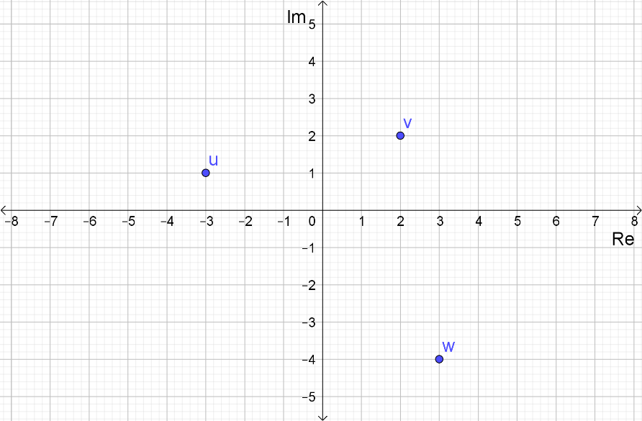

$z_{1}=2u$

$z_{2}=w-2\overline{v}$

$z_{3}=iu$

$z_{4}=3-wi+v$

**Question 9**

**[4 marks]**

1. What is the matrix for the transformation T: (x, y)  (2x – 3y, 5x + y)?
2. Find the image of the triangle A(3, –2) B(5, 3) C(1, 6) under the transformation T.

**Question 10**

**[7 marks]**

The vertices of a rectangle are $A(-2,-1)$, $B(5, -1)$, $C(-2, 3 )$ and $D(5,3).$

Transformation $P$ is a translation by vector $\left[\begin{matrix}-2 \\ 5\end{matrix}\right]$.

1. State the coordinates of the image of $A$ after the rectangle is transformed by $P$.

(1 mark)

The transformation matrix Q is $\left[\begin{matrix}0 \\ 5\end{matrix} \begin{matrix}4 \\ 0\end{matrix}\right]$.

1. State the coordinates of the image of $B$ after the rectangle is transformed by $P$ then $Q$.

(2 marks)

1. Find the area of the rectangle after it has been transformed by $P$ then $Q$.

(4 marks)

**Question 11**

**[3 marks]**

Use matrices to find the image of the line $x-3y=1$ after it is reflected in the line $y=-x$.

**Question 12**

**[5 marks]**

The triangle with vertices $O(0, 0), A(2, 0)$ and $B(0, 3)$ is mapped to the triangle $O’A’B’$ by the transformation represented by the matrix $\left[\begin{matrix}4 & x \\ x & y\end{matrix}\right]$. The area of triangle $O’A’B’$ is 36 cm2 and has coordinates $(8, 0).$ Find the value of $x$ and $y$.

**Question 13**

**[4 marks]**

A point A is transformed by matrix M to A’ and then by matrix N to A’’, where M is the transformation that rotates 30 $°$ anti-clockwise about the origin and N is the transformation that dilates by a scale factor of 4 in the y direction.

Find the single matrix that will transform A’’ back to A.